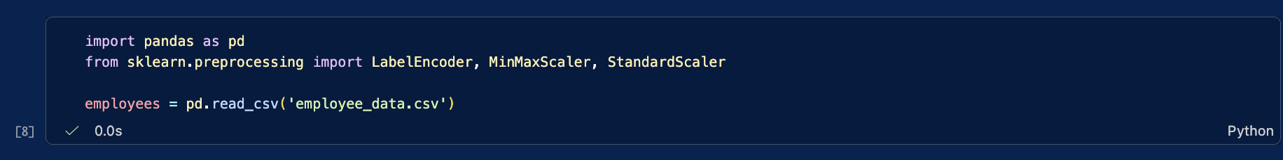

cell 1: import tools and load the employee data
this cell imports pandas and some preprocessing tools from scikit-learn, then reads employee_data.csv into a dataframe called employees.

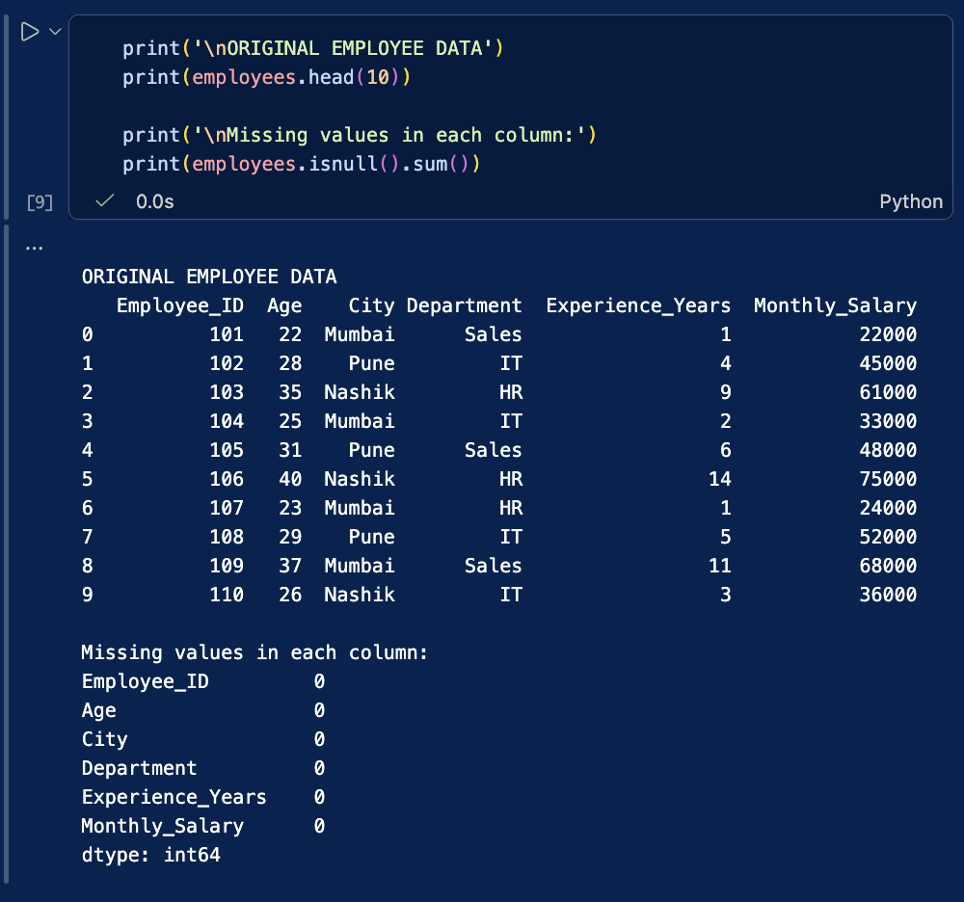

cell 2: check the data
this cell displays the first 10 rows and counts missing values in each column.

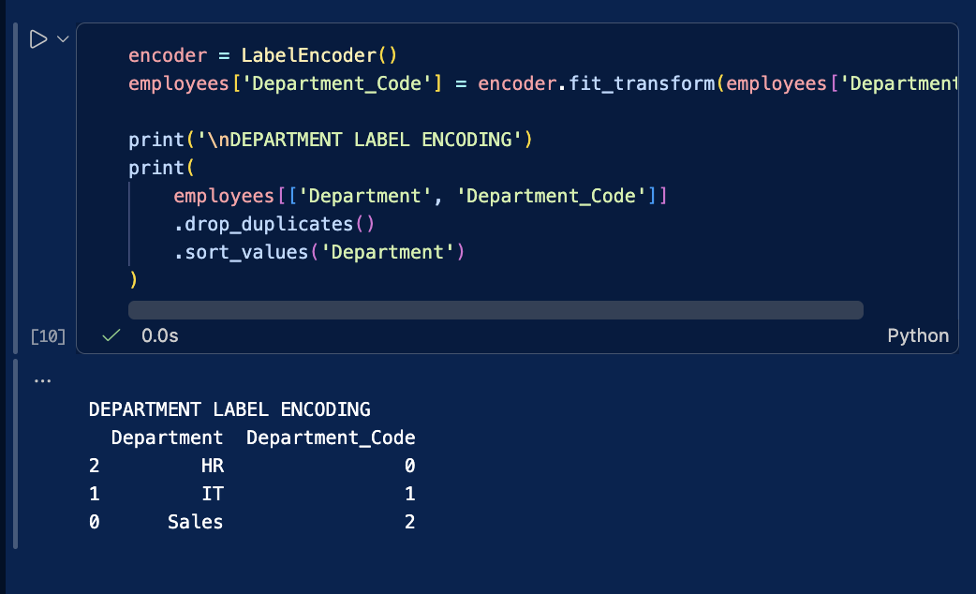

cell 3: encode department names
this cell converts department names into number codes and displays the mapping.

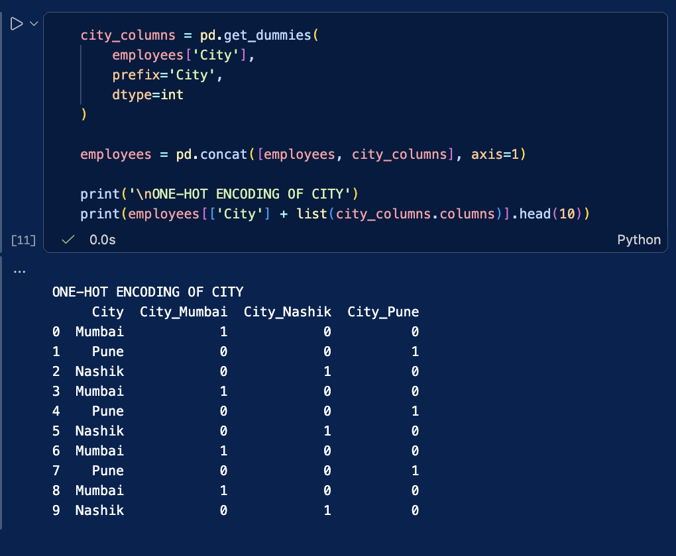

cell 4: encode city names
this cell creates a separate 0/1 column for each city and displays the results.
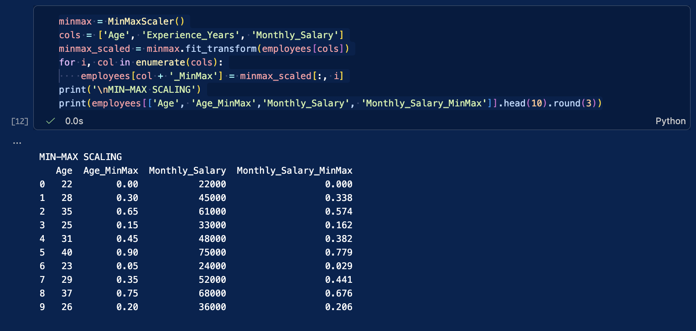

cell 5: apply min-max scaling
this cell scales age, experience, and salary values to a range between 0 and 1.

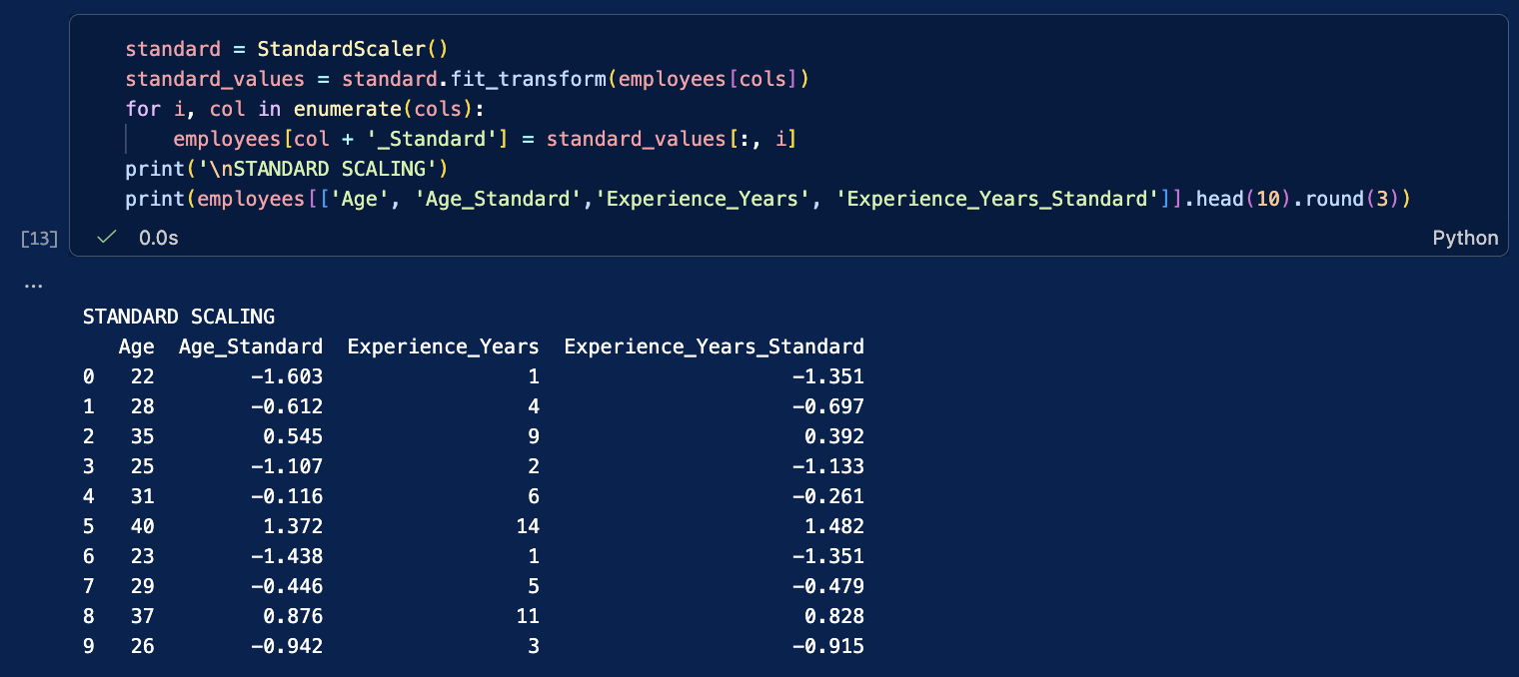

cell 6: apply standard scaling
this cell standardizes age, experience, and salary values so they are centered around zero.

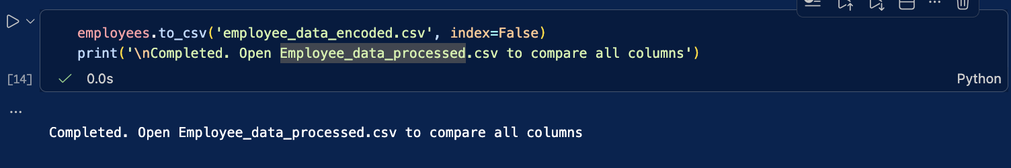

cell 7: save the processed data
this cell saves the updated employee data to employee_data_encoded.csv.

this notebook loads employee data, checks for missing values, converts department and city names into machine-readable columns, scales age, experience, and salary values, and saves the processed data to a new csv file.
Name : Daksh Ranjan Srivastava
Roll no : 150096725087

